LETS UPGRADE-LINUX ADMINISTRATION

ASSIGNMENT-2 DAY 5

By

Rasika kulkarni

1. Add a 10GB disk to the CentOS.

2. Create 2 Partitions 4GB and 6GB of Space respectively.

3. Format 4GB with xfs and 6GB with ext4 file system.

4. Mount 4GB and 6GB in /data and /music directory respectively.

5. Create one file of 1GB in each of the mount point created above.

6. Verify the disk Consumption and disk space free in the mounted partitions.

**Q1. 1. Add a 10GB disk to the CentOS.**

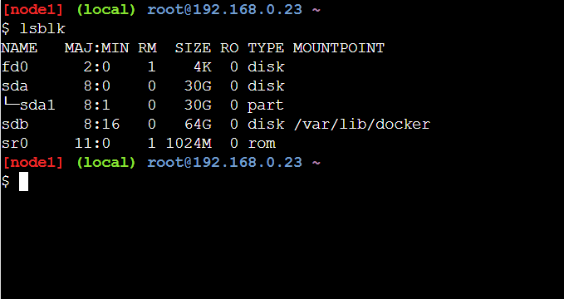

**Q2. 2. Create 2 Partitions 4GB and 6GB of Space respectively.**

**Ans: Creating partitions of 4GB**

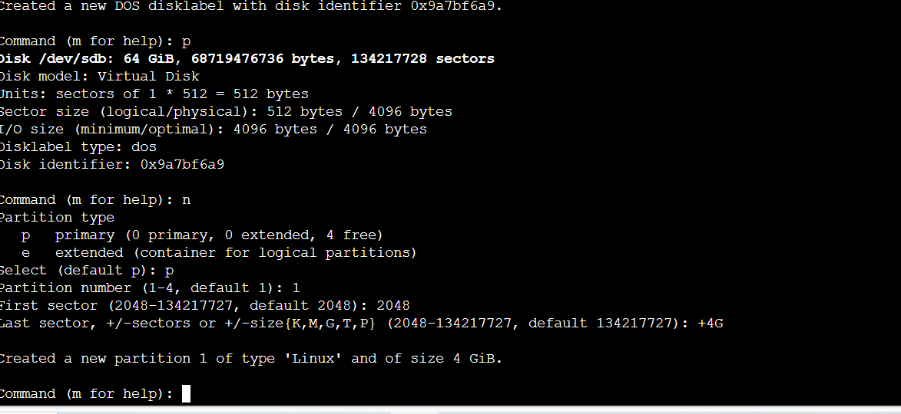

**Creating partitions of 6GB**

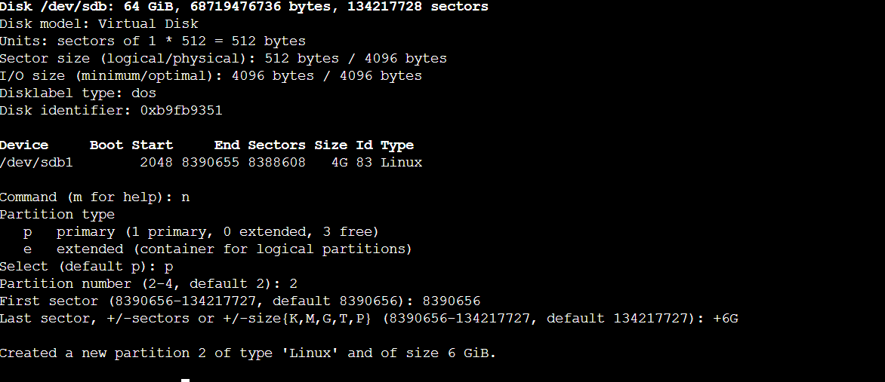

**Q3. Format 4GB with xfs and 6GB with ext4 file system.**

**it can be done using mkfs command**

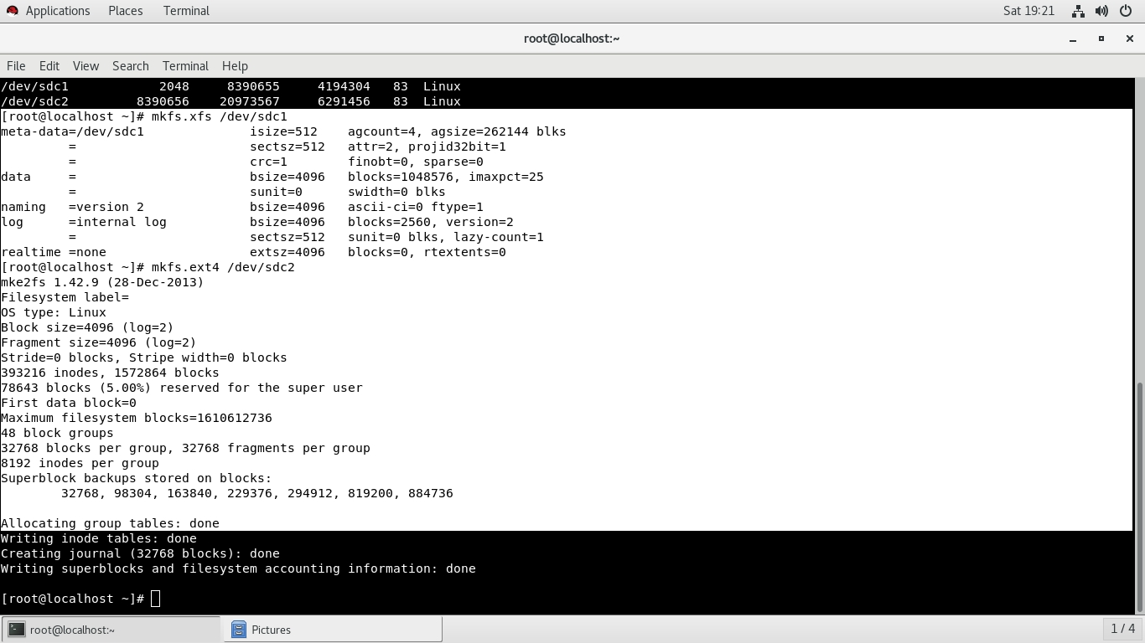

**Q4. Mount 4GB and 6GB in /data and /music directory respectively.**

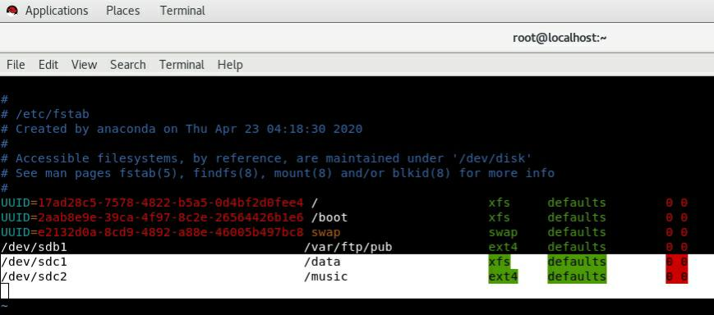

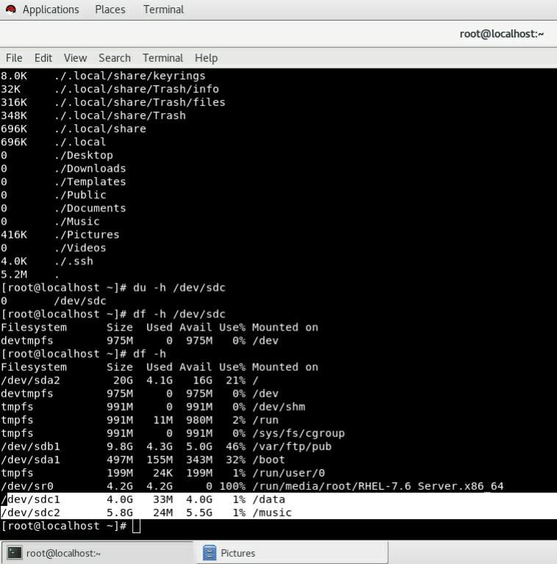

**5. Create one file of 1GB in each of the mount point created above.**

Creating 1Gb File Using **seq > 1000000** Command

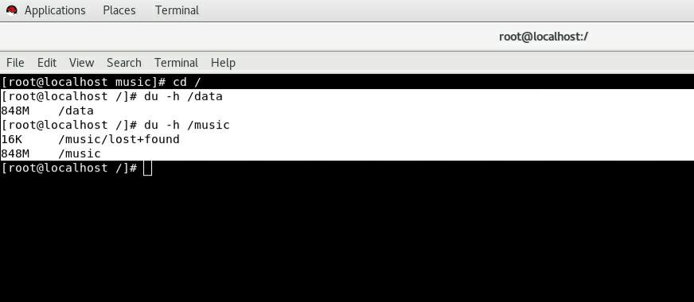

**Q6. Verify the disk Consumption and disk space free in the mounted partitions.**

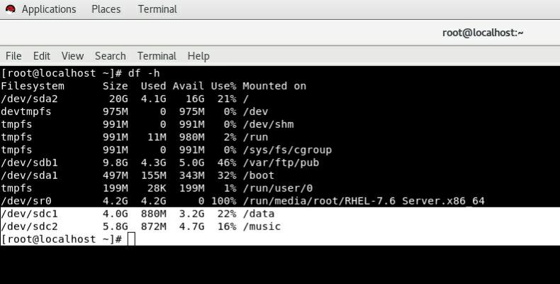**verifying disk consumption using df-h command**